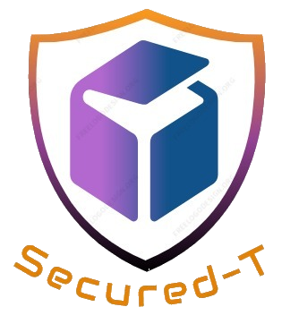

**SECURED-T**

**Write-Up**

**Version 1.0**

**[17 August 2017]**

**Brief Description**

The Secured Online Assessment System, known as Secured-T, offers a secured and controlled test environment by making use of the Software Defined Network (SDN) model as shown in the diagram below.

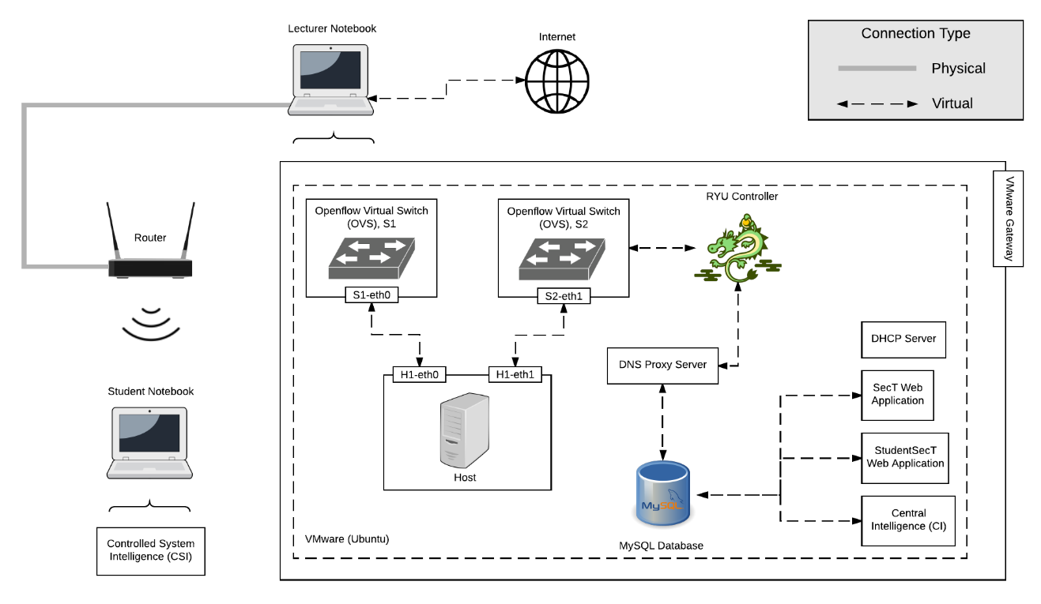

It is designed for lecturers to facilitate online assessments and for students to use their own notebook during the online assessment. Secured-T supports open book examinations and prevents students from cheating in the form of communication amongst one another.

**Outcome**

Secured-T has successfully delivered the essentials and dismissed several concerns of our end users. Nonetheless, we think that Secured-T is currently not the perfect solution to prevent students who are determined to cheat. Further enhancements to the system with our recommended improvements could drastically reduce the possibility of fraudulent activities piloted by the students. Additionally, on top of solving the project problem, Secured-T has many potential usages which provides plentiful space for development, thus reaching out to a wider scope of end users.

**Potential Applications**

Secured-T can also be used in a classroom environment during lectures or practical lessons. This allows lecturers to monitor the weaker students and control website access so that students could pay attention in class.

In addition, it can plausibly be used for easier parental control in households. This allows parents to be able to restrict and monitor their children’s activities on the internet.

Last but not least, it could potentially be used in highly confidential company where sensitive information is involved and security is of high importance. This allows for the limitation of websites that can be accessed and monitor any suspicious online activities.